How Do I Print My Syllabus?
The official syllabus for each course taught at Tri-County is contained in the College’s Curriculum Management System, WIDS. When posting or distributing your syllabus to students, please use the official document from WIDS. The syllabus contains elements that are the same for all sections of a course no matter the instructor. Those elements include Course Prefix & Number, Course Title, Course Description including Prerequisites/Co-requisites, Career Cluster, Total credits, Total hours, Type of Instruction, (Lecture/Laboratory), Instructional Level (Transfer Course, Non-Transfer Course), Grading Scale, Textbooks, Bibliography, Learner Supplies, Guidelines, Course Fees & Amount, Related Outcomes (General Education, Program, External Standards), Competencies, Competency Assessment Tasks, Competency Assessment Task Criteria, and Grading Scale. Any additional information that is specific to your course that you want to supply to your students should be distributed in the form of an addendum to the syllabus. Please verify that no information distributed contradicts any information in the official syllabus.
To print your syllabus go to http://tctc.wids.org
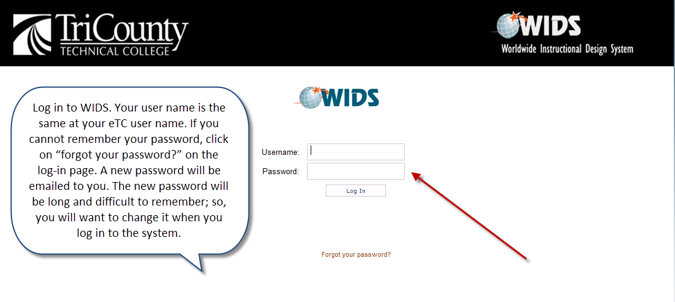

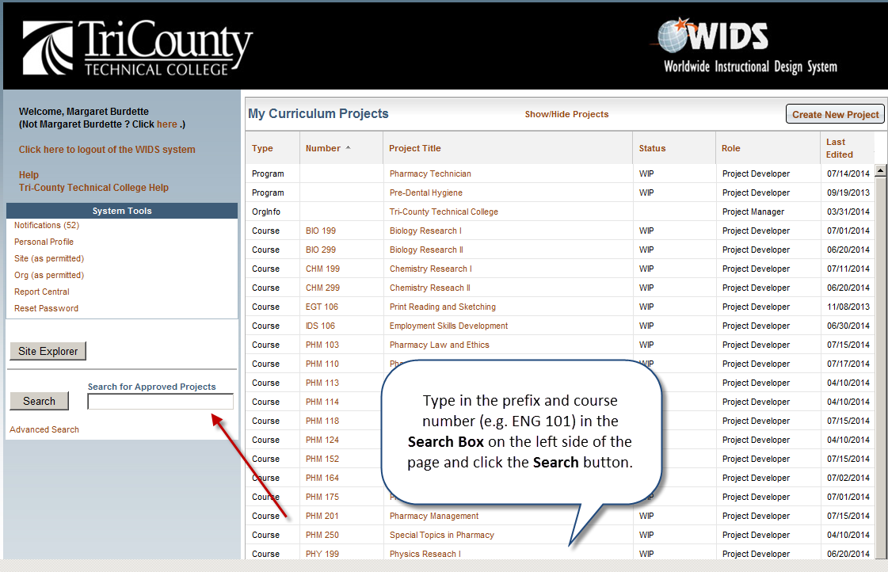
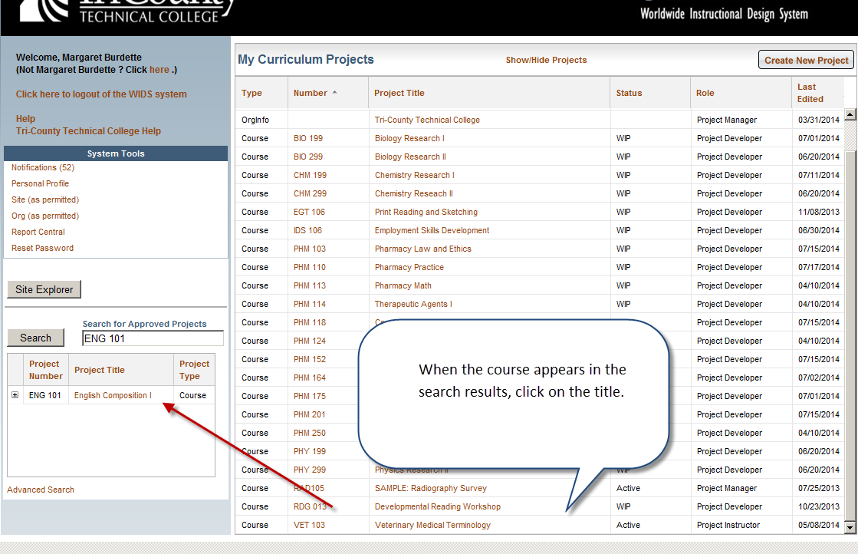
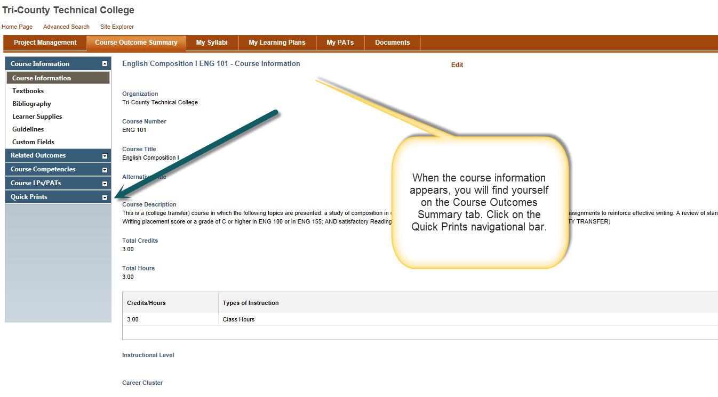
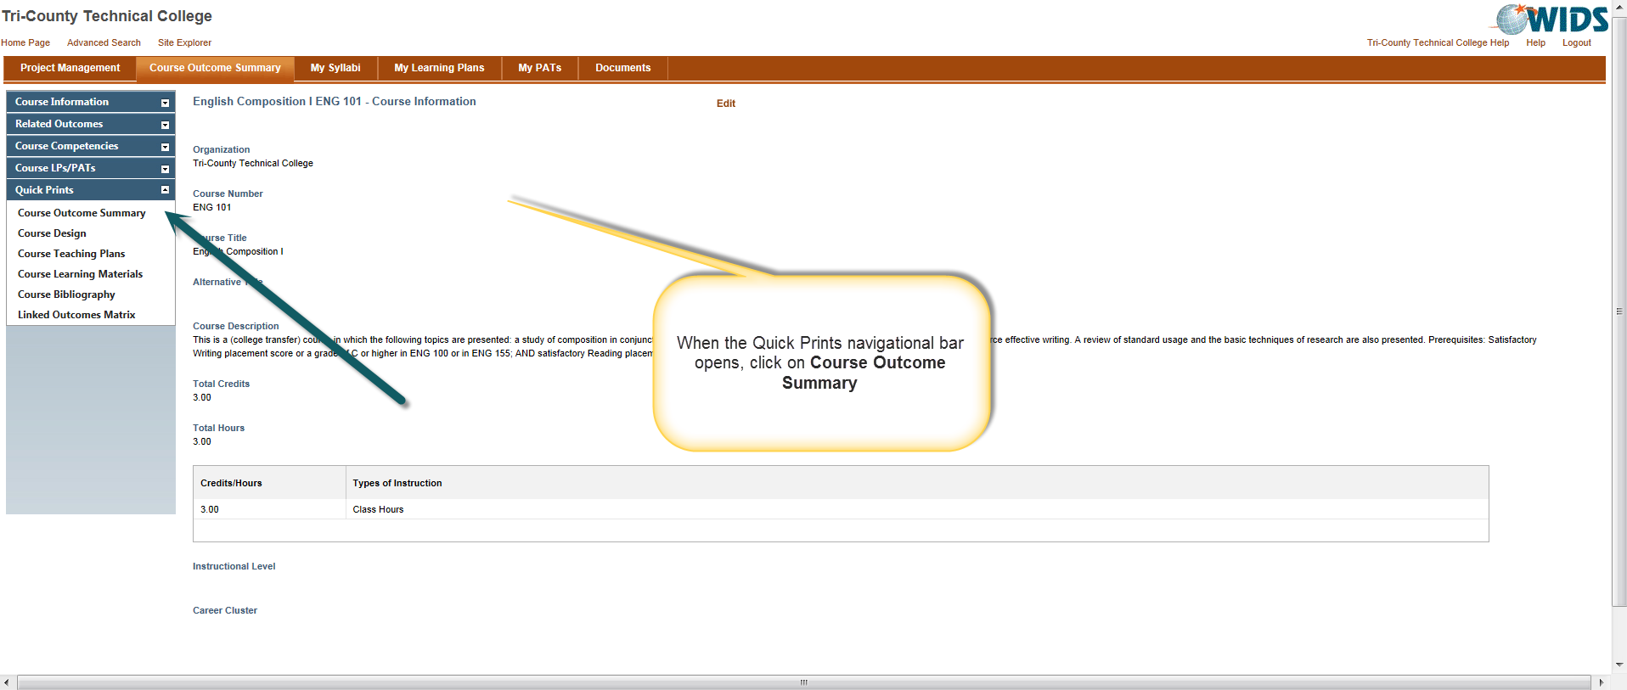

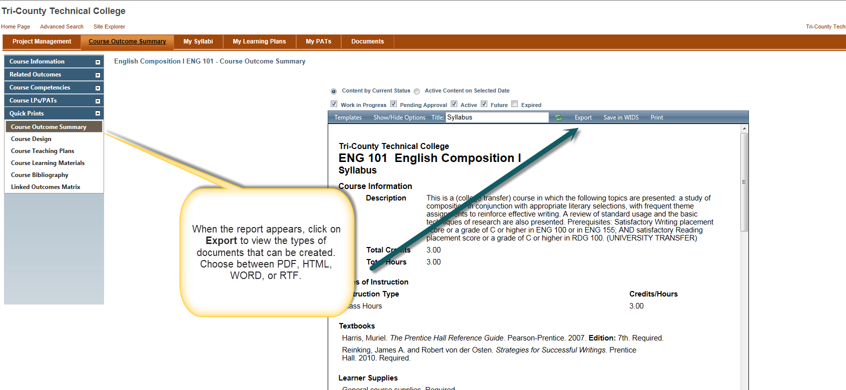

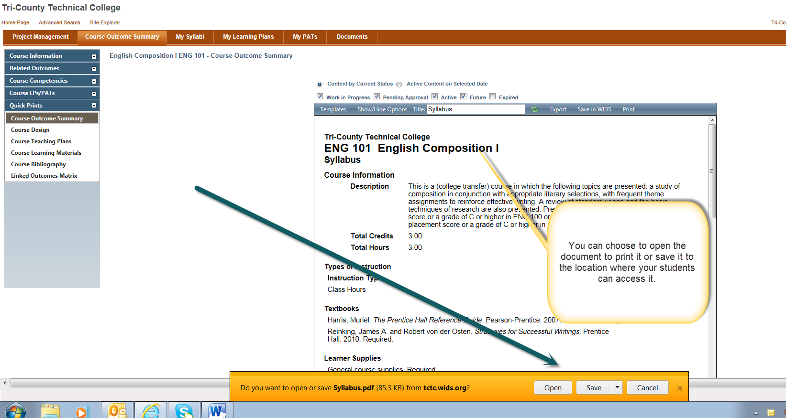

If you need assistance with this process, please contact Margaret Burdette (mburdett/1814)

